PART ONE

RCMP Police Dog Services Honour Roll Dedication
Regina Wednesday, MAY 21,2025, 1330, hrs

The RCMP Veterans Association Foundation has partnered with the RCMP Heritage Museum to honour the 22 RCMP Police Service Dogs who have fallen in the line of duty. Each Honour Roll member will have a walkway brick placed along the Princess Royal Walk at the museum.

https://rcmp.ca/en/depot/police-dogs/police-service-dog-honour-roll.

All serving and retired RCMP Members (including dog handlers) are cordially invited to attend this long overdue recognition of our K9 partners. If any members who have a partner named on the honour roll and wish to be part of the dedication ceremony, they are encouraged to contact me asap.

The RCMP Veterans Foundation has no ability to cover any travel costs etc. for attendees.
There will be a complimentary reception following the dedication at the Depot Division Officers Mess.

A block of rooms has been set aside at the Hotel Saskatchewan (Delta/Marriott) at a room rate of $160.00/+ taxes. DEADLINE TO BOOK this rate is MONDAY APRIL 21,2025
See attached link
https://www.marriott.com/event-reservations/reservation-link.mi?id=1740069262069&key=GRP&guestreslink2=true&app=resvlink

PART TWO

TO ALL PSD Handlers -Currently Serving and Retired
On May 21st, 2025, a bronze statue (see attachment) will be unveiled on the Princess Royal Walk at the RCMP Heritage Centre in Regina. The beginning of a new brick mural will also be laid on the walkway paying tribute to the 22 RCMP Service Dogs we lost in the Line of Duty over the years. Adjacent to the brick mural, is the dedicated RCMP Service Dog pillar which currently hosts the names of "the Originals", plus the names of 48 RCMP Police Service Dogs on the first full plaque.
The Friends of the RCMP Heritage Centre are actively working on the 2nd plaque of 48 names, to be placed in time for the unveiling of the statue. The RCMPVA Foundation and two RCMP Veterans have donated in excess of $100,000 to make the Princess Royal Walk the official home of our service dogs and those on our Honour Roll. This is significant to us as Handlers and more importantly it provides a platform to memorialize our four-legged partners that work so hard on behalf of Canadians.
In celebration of this upcoming event as well as the dedication of the Handlers and dogs who have served our country, The Friends are offering all PSD Handlers a 50% discount to place your PSD's name and regimental number on the PSD pillar in time for the unveiling on May 21st: that is $150 savings on every donation.
If have not yet put your dog’s name yet on a Pillar, PLEASE take advantage of this great opportunity and STAKE YOUR CLAIM at the undernoted link by Monday March 31, 2025. To try an ensure your dog’s name plate is ready by the dedication date for you to place if you so choose. Please make every effort to place an order asap.
https://www.rcmphcfriends.com/pillars-of-the-force/
** Disregard the preformatted amounts on the electronic claim form and insert the promotional amount of $150. Please contact "The Friends" at friends@rcmphc.com if you have any questions or issues completing the form. A charitable tax receipt will be issued.

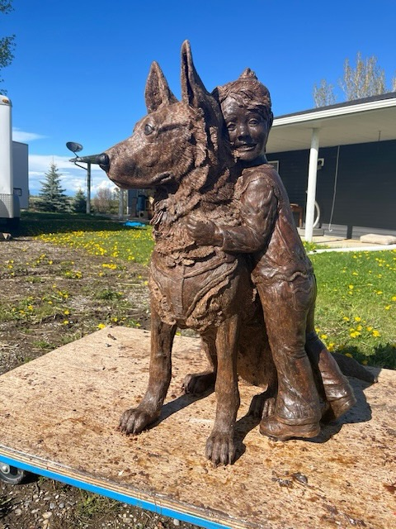

Cheers
Dave Mitchell
Director RCMPVA -Foundation
Email: davidjmitchell28@gmail.com

